**IMPLEMENTATION AND TESTING:**

Recently, in-depth CNN-based learning models have been used to address computer vision problems. Using CNN's in-depth design based on ResNet-50, Vgg-16 models combined with transfer learning techniques to separate Pneumonia Chest X-ray image data between a normal patient and a Pneumonia patient. Transfer learning also helps to deal with insufficient information and modeling time to practice. The image below shows how the image is categorized:

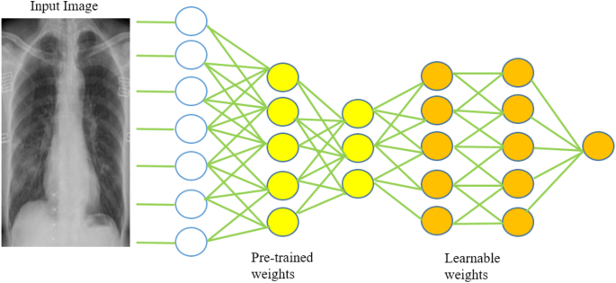

**Image Net:**

Image Net is a research project to create a very large database of images with annotations, for example images and their displays.

The images and their descriptions have been the subject of the ImageNet Large Scale Visual Recognition Challenge or ILSVRC since 2010. The result is that research organizations fight them on predefined data sets to see who has the best model for visualizing objects in images.

For segmentation work, images should be divided into 1,000 unique categories. Over the past few years the most advanced models of convolutional neural network have been used to overcome these challenges and the results of activities exceed human performance.

**Resnet50:**

Working to train deep networks new construction comes with a residual learning framework known as ResNet. In this design the layers of the network are redesigned by learning using residual functions in relation to the installation of the layers. ResNet is also referred to as a residual network that adapts to the idea of ​​skipping connections to deal with the problem of extinct gradient. This prevents visible distortion as the network becomes deeper and more complex. ResNet alternative ResNet-50 is used as one of the models. This used a 50-layer network and was trained using the ImageNet database. The ResNet-50 building consists of a convolutional layer, 4 convolutional blocks, a large pool, and a standard dam to deal with the deterioration of accuracy. This helps generate deeper CNNs by maintaining accuracy. The development of ResNet-50 provided developers with a way to build deeper CNNs without compromising accuracy. ResNet-50 was among the first CNNs to use the batch normalization feature.

ResNet-50 represents the Residual Network where 50 looks at the number of layers. ResNet used to solve the problem of gradient explosion and destruction it encountered while training a deep neural network model. First trained on more than a million images set in the ImageNet data set. This pre-trained model is used for training in chest X-ray image databases. ResNet 50 has 48 layers of convolution, 1 average pool layer and 1 max pool layer and has 3.8 × 109 point functions. X-ray images are fed by model and various parameters are set as size of batch equals 32, epoch value is equal to 50 and literacy rate is 3e-2. Networks with a large number (even thousands) of layers can be easily trained without increasing the percentage of training error.

**ResNet uses below blocks to construct the entire network:**

**Convolution Block:** Convolution is utilized for many things like calculating derivatives, identify edges, apply blurs and so on and all this is done utilizing a "convolution kernel".

The conv block helps to modify and rebuild the incoming data so that the output of the first layer matches dimensions of the third layer so they can be added.

**Pooling:** Pool insertion layers are used to reduce the size of the feature maps. In this way, reduce the number of parameters to be read and the number of computers generated in the network. The integration layer summarizes the features present in the feature map region formed by the convolution layer.

**Identity Block:** ResNet build block is called residual block or ID . The residual block is actually when layer performance is immediately deployed in a deep layer on the neural network.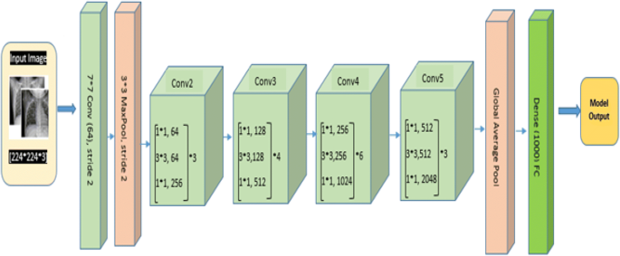

Reconstruction of the ResNet-50 Pneumonia Chest X-ray image section

**Flow:**

First we took a chest xray of data, we saw that it is the highest rating of pneumonia class images, so we measured the data first by keeping the same number of images in both classes in the train folders and verification.

Next, we have selected resnet50 algorithm first, we have trained the resnet50 model on these images, we have used pre-trained weights for initial layers of resnet50, That pre-trained model is actually trained on Imagenet dataset. Now, we have trained the final layers of the resnet50.

We have taken proper care while training the algorithm, we have ran the training for 50 epochs. Now, we have saved the best weights during this training process. We are selecting the best weights by testing the model on validation data after every epoch.

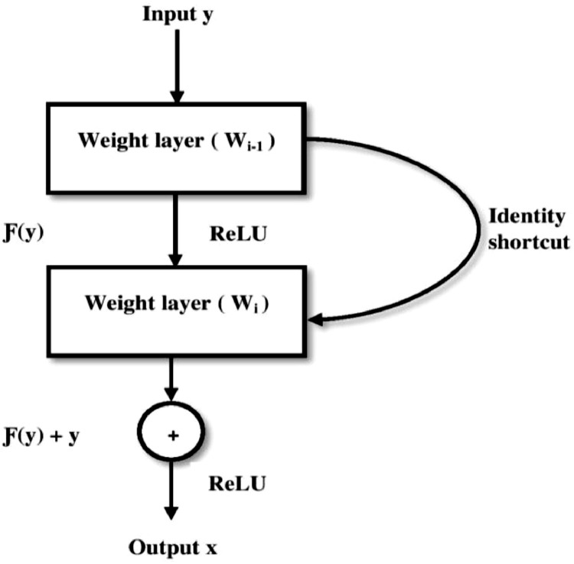

Workflow of ResNet-50 model

**Vgg16:**

The Vgg16-trained learning model is generated by a benchmark benchmark dataset similar to the ImageNet image recognition task. Trained for millions of images using ImageNet in a multi-classroom environment. The main motivation for using weight loss learning, bias and features of a pre-trained model can be transferred to our scheme instead of the original. This is achieved by applying these parameters while training in the X-ray image database. Training a CNN model from scratch is time-consuming compared to training a pre-trained model and cheaper mathematically if the database contains a small number of images. The Vgg-16 model has 16 network layers built into the ImageNet database whose main purpose is the recognition and classification of images. Chest X-ray images provided for the model are compiled and made to a size of 224 × 224. . The Vgg-16 model consists of a 13-layer convolution using 3 × 3 convolution filters, 5 multi-layer composites for sample reduction, 2 fully integrated layers and a dense and flat layer.

Visual Geometry Group (Vgg) created the 41-layer Vgg16 network. Vgg simplifies the process by making 3 × 3 filters in each layer. Use of

equal and moderate filter limitations at Vgg can produce more complex features and lower processing compared to AlexNet.

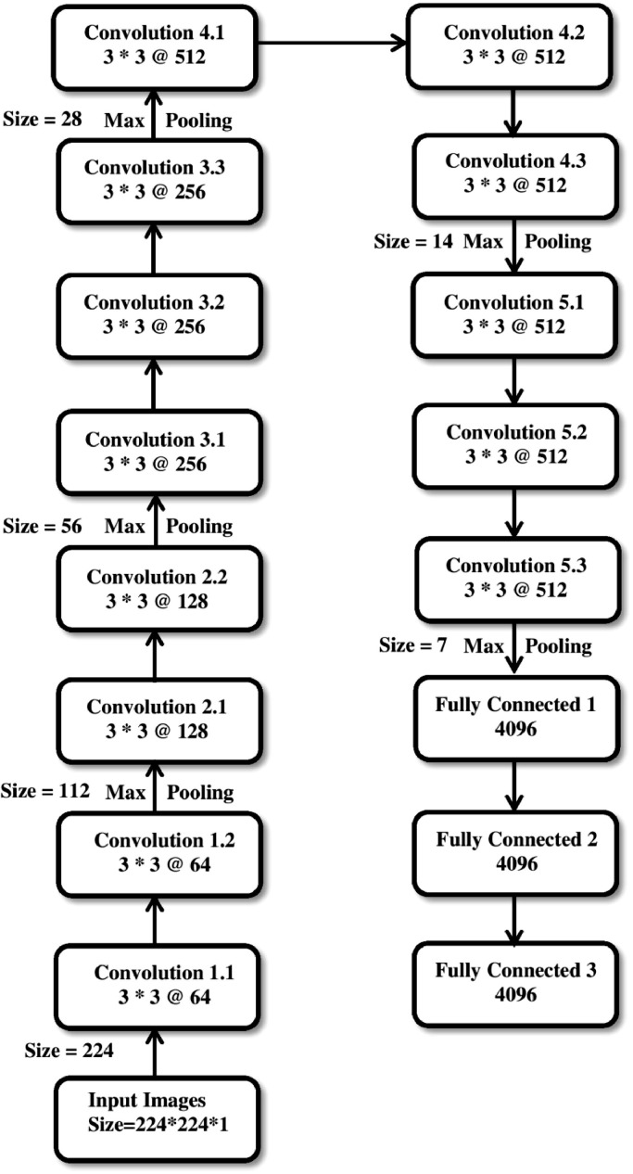

Layers construction of VGG-16 model

**Vgg16 Implementation**:

1. Collect the database. By creating any model, the basic requirement is a

data capture.

2. Then train the model using VGG16.

3. Download the VGG16 weights and freeze them.

4. Install new layers of fine tuning.

5. Check and use the model.

6. Upload the model for testing purposes.

7. Launch the model.

8. Evaluate Model.

9. Learning curves.

**Why Max pooling is used in Vgg16:**

Max pooling chooses the brighter pixels from the image. When classifying the dataset utilizing CNN, max pooling is utilized because the background in these images is made black to Lessen the computation cost. Max pooling is finished by applying a max filter to (usually) non-overlapping subregions of the underlying representation.

**Flow:**

First we have taken the chest xray dataset, we have seen that it’s highly class imbalance towards pneumonia class images, so we have balanced the data first by keeping same number of images in both the classes in train & validation folders.

Next, we have selected vgg16 algorithm first, we have trained the vgg16model on these images, we have used pre-trained weights for initial layers of vgg16, That pre-trained model is actually trained on Imagenet dataset. Now, we have trained the final layers of the vgg16.

We have taken proper care while training the algorithm, we have ran the training for 50 epochs. Now, we have saved the best weights during this training process. We are selecting the best weights by testing the model on validation data after every epoch.

**RESULTS AND DISCUSSION:**

### Performance-metrics:

To measure the performance of pre-rained CNN architectures to classify the Chest X-ray images we use accuracy which uses the below terms:

* True-Positiveness : It shows that a common case with pneumonia is correctly predicted as normal with pneumonia respectively.
* True-Negativeness : It shows that the normal case is predicted as well as the normal.
* False-Positiveness : It shows that this case is common and predicted as a case of pneumonia.
* False-Negativeness : It shows that the case is pneumonia and is predicted as a common case.

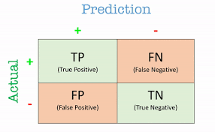

**Accuracy:**

Accuracy is defined as the total no. of records separated by the total number of records in the database.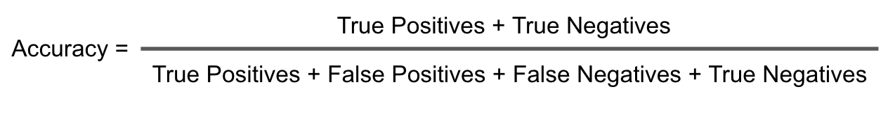

This accuracy measure will work best shown in the equation when we have

the same number of images for both categories. Therefore, to predict the accuracy of the models we use other metrics.

### We played a comparative analysis to demonstrate the effectiveness of our proposed framework. We have shown the results of our proposed framework. We performed tests using Vgg-16 on 293 non-preprocessed X-rays that confirmed pneumonia cases and found 83.5% accuracy in separating the data from healthy patients with pneumonia. We performed another in-depth study based on 600 non-preprocessed X-ray samples and distinguished between pneumonia and normal using the ResNet-50 model and achieved 78.5% accuracy.

### Pre-processed images can not be classified correctly because necessary data present in the image gets lost because of pre-processing . so, they can not produce good results.

### The below pre-processed images got classified using vgg16 and resnet50:

### 

### The below non-preprocessed images got classified using vgg16 and resnet50:

### 

### Graphs:

### Vgg16-Accuracy Comparison:

### Accuracy and loss graphs of the VGG-16 model using the original dataset | Download Scientific Diagram

### Resnet50-Accuracy Comparison:

### 

### From test scores, we can say that the proposed method accurately presents non-preprocessed images in all classrooms as normal with pneumonia. We can therefore say that the fine-tuning of CNN's pre-trained facilities can be used as one of the most useful methods in the medical field for the separation of Chest X-ray images.

**Conclusion:**

Chest X-ray is the most well known intend to detect lung lesion and deep learning is a good tool to help the diagnosis. For classification undertakings of chest X-ray images, it is promising to adjust existing deep networks because of limits of data size, labeling and computer hardware. we analyze chest X-ray data set, plan a hierarchical classification structure and present a recently-designed convolutional neural network to detect Pneumonia in chest X-ray images. Furthermore, we can somewhat change the architecture to learn more details and extract more discriminative information. It additionally demonstrates that our model can learn more useful information and in this manner acquires better performance. Plus, it indicates that training images with higher resolution and bigger number can promote the classification performance. In a word, the key of good outcome is making every effort to learn more useful and accurate features, no matter through planning a more proper CNN or utilizing more data.

The analysis has been carried out to classify Normal Chest X-Ray and Pneumonia images. Early diagnosis of Pneumonia patients is significant for curing the disease. we have utilized deep CNN based approach using transfer learning to differentiate between pneumonia and normal. We have deployed two pre-trained CNN models to investigate the transfer learning techniques and conclude that fine tuning the pre-trained CNN models can be effectively deployed to a limited class dataset. X-ray imaging is an important method for diagnosing and assessing Pneumonia.

Deep learning is applied to chest X-rays of patients has shown promising outcomes in the identification of Pneumonia. We worked on lightweight convolutional network architecture with two backbones (VGG-16, and ResNet50 pre-trained on ImageNet dataset) for detecting Pneumonia by using images of chest X-ray . Indeed, with a limited number of images in the Pneumonia class, promising outcomes achieved by the network on the test dataset with accuracy value of more than 90% for the two models. We have utilized pre-trained expertise to improve Pneumonia diagnostic efficiency. Our high accuracy findings can be useful to the doctors and researchers to make decisions in clinical practice. We would like to emphasize on the fact that it will be feasible to improve the training accuracy and detection rate with more images and new data collected for the Pneumonia class. Our results additionally demonstrated the application of generative adversarial network-based augmentation techniques can add to accuracy improvement and can produce a more generalized and a robust model.

**FUTURE ENHANCEMENT:**

Our study has several impediments and they can get better in the future. In particular, a thorough analysis will need considerably more data about patient, particularly who are suffering with Pneumonia. By seriously fascinating methodology for the future will mainly concentrate on determine the patients having little and severe Pneumonia complications, while these complications can not be correctly envisioned on images of X-ray, or they can not be visualized. To test the unwavering quality of the architecture that has been made, the next study can be characterized more than 2 classes of chest x-ray images. CNN is a promising strategy of image process and the loss function and architecture are as yet the accentuation of our further research.

Furthermore, we will attempt to utilize our approach on bigger datasets, to tackle other medical problems like cancer, tumors and so forth and furthermore on other computer vision fields as energy, agriculture, and transport in the impending days. Future research directions will incorporate the exploration of image data augmentation methods to improve accuracy even more while avoiding overfitting. We observed that performance could be improved further, by expanding dataset size, using a data augmentation approach, and utilizing hand-crafted features, in the future.

In future, if clinical notes and other metadata, for example, need for intubation and supplemental oxygen are provided, it is feasible to train mixed image and metadata models. These mixed models could give prognostic and severity predictions and be profoundly valuable for risk stratification, patient management, and customized care planning in this critical resource-constrained pandemic scenario. All models created in this work have a memory impression below 100 megabytes. Subsequently, another future direction from this research will broaden the model implementation on conventional smartphone processor to do quick and modest on-device inference . To give a proof of concept of transferring the capability of deep learning models on mobile devices, we would like to build on our previous experience in transferring such models utilizing the TensorFlow lite (TFlite) library .